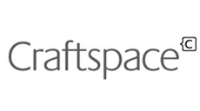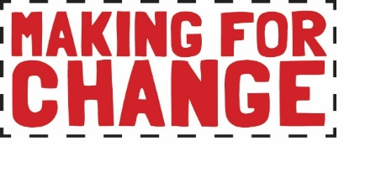

Application: Creative Lead
- Curator
- Documenter & Digital

Please read the job descriptions for before completing this application form.

Email your application to info@craftspace.co.uk by 5pm on Sunday 2nd February 2020. Click here to complete your Equal Opportunities Form online or download as a word document from Craftspace website Team page.

About You
Name:
Preferred pro-noun (e.g. he/him, she/her, they/them):
Date of Birth:
Address:
Mobile/Telephone number:
Email:
Website/web spaces (work)
Social media (work):

Which role are you applying for?
Curator
Documenter & Digital

Please tell us why you are applying for this role (100 words max):

What would you like to gain from this role and how will it help your future career development (150 words max)?

Do you have any specific interests, knowledge or qualifications that relate to this role (150 words max)?

Do you have any previous experience (paid or voluntary) that relates to this role (150 words max)?

Access
Please tell us about any access needs for which you will require additional support:

Time Commitments
Please tell us about any time commitments you will have from February 2020 up to and including June 2020 (work, study, holiday or other commitment):

Interview
Will you be available to attend an interview on Monday 10th February 2020?

Planning meeting
Will you be available to attend a planning meeting on Monday 24th February 2020?

Email your application to info@craftspace.co.uk by 5pm on Sunday 2nd February 2020. Include your:
- Completed application form

Privacy Notice
Craftspace is registered as a data controller. (Registration Number: Z5906900) Craftspace tries to meet the highest standards when collecting and using personal information in accordance with data protection law. Read and download our full privacy notice on our website.

craftspace.co.uk
Unit 15, Highgate Craft Centre, 8 Highgate Square, Birmingham B12 0DU
TEL 0121 608 6668 E-MAIL info@craftspace.co.uk

